**Empirical Project 2**

**Stories from the Atlas: Describing Data using Maps, Regressions, and Correlations**

The [Opportunity Atlas](https://www.opportunityatlas.org/) was publicly released on October 1, 2018, and an accompanying [article](https://www.nytimes.com/2018/10/01/upshot/maps-neighborhoods-shape-child-poverty.html) appeared on the front page of the *New York Times*. The Opportunity Atlas is a freely available interactive mapping tool that traces the roots of outcomes such as poverty and incarceration back to the neighborhoods in which children grew up. Policymakers, journalists, and the public have begun to explore the Opportunity Atlas, casting new light on the geography of upward mobility in communities across the country. As an example, see Jasmine Garsd’s [recent analysis](https://www.npr.org/2018/10/04/654085265/the-american-dream-one-block-can-) for the New York City neighborhood of Brownsville in Brooklyn.

In this project, you will use the Opportunity Atlas mapping tool and the underlying data to describe equality of opportunity in your hometown and across the United States. (If you grew up outside the United States, you may select a community in which you have spent some time, such as DC. Please ok your choice of neighborhood with the instructor.)

The end product will be a 4-6 page narrative (or story) in which you describe what you have learned from the Atlas. The page limit is just meant to be a guideline. The next page lists specific analyses and questions that your narrative must address. Please enter the stata command and output below each question and the interpret the output.

This project focuses on the following methods for descriptive data analysis. (The later empirical projects you will do in this class will be focused on causal inference and prediction).

1. *Data visualization.* Maps are a powerful way to present descriptive statistics for data with a geographic component. You will use maps to display upward mobility statistics for the Census tracts in your hometown.
2. *Regression and correlation analysis.* You will use linear regressions and correlation coefficients to quantify the statistical relationship between upward mobility and potential explanatory variables.

The Stata data file that you will use in this assignment, atlas_new.dta, contains an extract of the Opportunity Atlas data. We have also merged several other variables, which you may use for the correlational analysis.

**Instructions**

Please submit your Empirical Project on Blackboard. Your submission should include:

1. A narrative as a word document (double spaced and including references, graphs, maps, and tables). Try to incorporate a summary statement after each analysis on what the takeaway is.
2. Stata do-file
3. Submissions for Part II and Part III should build on the Part I submission.

**Specific questions to address in your narrative**

**PART I:**

1. Start by looking up the city where you grew up (or any other city of your choice) on the [Opportunity Atlas](https://www.opportunityatlas.org/). Zoom in to the Census tracts around your home. Figure 1 in your narrative should be a map of the Census tracts in your hometown from the Opportunity Atlas. Examples for Milwaukee, WI (where Professor Chetty grew up) and Los Angeles, CA (discussed in Lecture 1) are shown on the next page. The text of your narrative should describe why you picked the census tract you are looking at, what are your general observations on the tract, and what data are being visualized.

The text of your narrative should describe the census tract you are looking at, what are your general observations on the tract (try to google some details about this area), and what data are being visualized. Examine *household income* and *incarceration rates* for different groups by income, race, and gender and include in your narrative. (25)

1. Now turn to the atlas_new.dta data set. How does average upward mobility, pooling races and genders, for children with parents at the 25th percentile (variable kfr pooled_p25) in your home Census tract compare to population-weighted mean upward mobility in your state and in the U.S. overall? Note that you will have to use the appropriate weights (weights_national and weights_state) to get the weighted averages. Do kids where you grew up have better or worse chances of climbing the income ladder than the average child in America? (25)

*Hint*: The Opportunity Atlas website will give you the tract, county, and state FIPS codes for your home address. For example, searching for “Lynwood Road, Verona, New Jersey” will display Tract 34013021000, Verona, NJ. The first two digits refer to the state code, the next three digits refer to the county code, and the last 6 digits refer to the tract code.

1. What is the standard deviation of upward mobility in your home county? Is it larger or smaller than the standard deviation across tracts in your state? Across tracts in the country? What do you learn from these comparisons? (25)
2. Now let’s turn to downward mobility: repeat questions (2) and (3) looking at children who start with parents at the 75th and 100th percentiles. How do the patterns differ? (25)

**PART II:**

1. Using a linear regression, estimate the relationship between outcomes of children at the 25th and 75th percentile for the Census tracts in your home county. Generate a scatter plot to visualize this regression. Do areas where children from low-income families do well generally have better outcomes for those from high-income families, too?
2. Next, examine whether the patterns you have looked at above are similar by race. Draw a scatter plot for each race.

**PART III:**

1. The data file tract_allCharacteristics.csv contains the Census tract level characters data downloaded from the Opportunity Atlas website. Load this data file into Stata, and merge it with atlas_new.dta. Please think wisely which **common keys** to use for merging the two datasets

Note that tract_allCharacteristics.csv is a complementary dataset to atlas_new.dta, and contains additional data on local characteristics at the Census tract level. For instance, atlas_new.dta only included poverty rate until 2010, while Characteristics.csv extends the data 2016. For your convenience, a Stata version of this .csv file has also been provided called atlas_character_ALL.dta

Using the Census tracts in your home county, can you identify any covariates which help explain variation in upward mobility that you have identified in the previous questions? (For this question, you could choose covariates that exists in the atlas_new.dta, or in the Characteristics.csv file.) Some examples of covariates you might examine include housing prices, income inequality, fraction of children with single parents, job density, etc. For 2 or 3 of these, report estimated regression coefficients along with their 95% confidence intervals. Formulate a hypothesis for why you see the variation in upward mobility for children who grew up in the Census tracts near your home and provide correlational evidence testing that hypothesis.

For this question, many covariates have been provided to you in the atlas_new.dta file, which are described under the “Characteristics of Census tracts” header in Table 1.

1. Putting together all the analyses you did above, what have you learned about the determinants of economic opportunity where you grew up? Identify one or two key lessons or takeaways that you might discuss with a policymaker or journalist if asked about your hometown. Mention any important caveats to your conclusions; for example, can we conclude that the variable you identified as a key predictor in the question above has a causal effect (i.e., changing it would change upward mobility) based on that analysis? Why or why not?

**Figure 1**

**Household Income in Adulthood for Children Raised in Low-Income Households**

**in Milwaukee, WI**

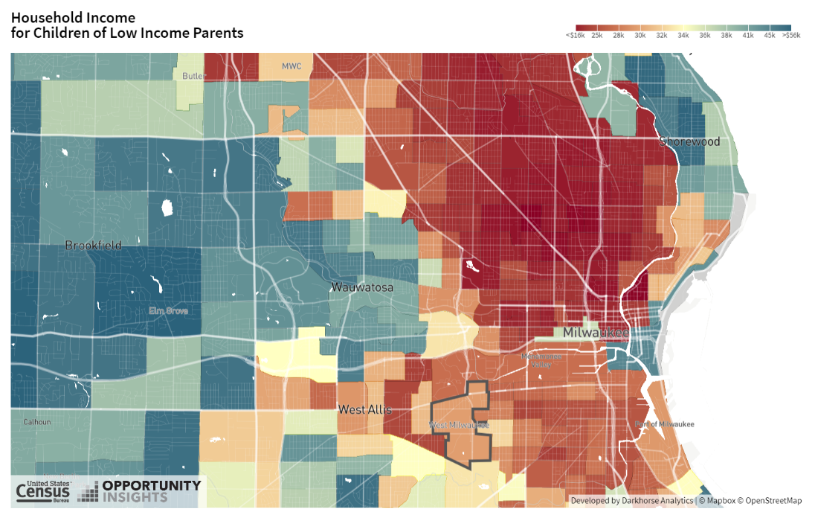

*Notes*: This figure shows household income at ages 31-37 for low income children who grew up in Census tracts near Milwaukee, WI. The image was saved from [www.opportunity-atlas.org](http://www.opportunity-atlas.org) by first searching for “Milwaukee, WI” and then clicking on the “download as image” button.

**Figure 2**

**Incarceration Rates for Black Men Raised in the Lowest-Income Households**

**in Los Angeles, CA**

**

*Notes*: This figure is from the [non-technical summary](https://opportunityinsights.org/wp-content/uploads/2018/10/atlas_summary.pdf) of the Opportunity Atlas and was discussed in Lecture 1.

**DATA DESCRIPTION, FILE: atlas_new.dta**

The data consist of *n* = 73,278 U.S. Census tracts. For more details on the construction of the variables included in this data set, please see [Chetty, Raj, John Friedman, Nathaniel Hendren, Maggie R. Jones, and Sonya R. Porter. 2018. “The Opportunity Atlas: Mapping the Childhood Roots of Social Mobility.” NBER Working Paper No. 25147](https://opportunityinsights.org/wp-content/uploads/2018/10/atlas_paper.pdf).

**Table 1**

**Definitions of Variables in atlas.dta**

|  |  |  |
| --- | --- | --- |
| **Variable name** | **Label** | **Obs.** |
| (1) | (2) | (3) |
| ***1. Geographic identifiers*** | | |
| *tract* | Tract FIPS Code (6-digit) 2010 | 73,278 |
| *county* | County FIPS Code (3-digit) | 73,278 |
| *state* | State FIPS Code (2-digit) | 73,278 |
| *cz* | Commuting Zone Identifier (1990 Definition) | 72,473 |
|  |  |  |
| ***2. Characteristics of Census tracts*** | | |
| *hhinc_mean2000* | Mean Household Income 2000 | 72,302 |
| *mean_commutetime2000* | Average Commute Time of Working Adults in 2000 | 72,313 |
| *frac_coll_plus2010* | Fraction of Residents with a College Degree or More in 2010 | 72,993 |
| *frac_coll_plus2000* | Fraction of Residents with a College Degree or More in 2000 | 72,343 |
| *foreign_share2010* | Share of Population Born Outside the U.S. | 72,279 |
| *med_hhinc2016* | Median Household Income in 2016 | 72,763 |
| *med_hhinc1990* | Median Household Income in 1999 | 72,313 |
| *popdensity2000* | Population Density (per square mile) in 2000 | 72,469 |
| *poor_share2010* | Poverty Rate 2010 | 72,933 |
| *poor_share2000* | Poverty Rate 2000 | 72,315 |
| *poor_share1990* | Poverty Rate 1990 | 72,323 |
| *share_black2010* | Share black 2010 | 73,111 |
| *share_hisp2010* | Share Hispanic 2010 | 73,111 |
| *share_asian2010* | Share Asian 2010 | 71,945 |
| *share_black2000* | Share black 2000 | 72,368 |
| *share_white2000* | Share white 2000 | 72,368 |
| *share_hisp2000* | Share Hispanic 2000 | 72,368 |
| *share_asian2000* | Share Asian 2000 | 71,050 |
| *gsmn_math_g3_2013* | Average School District Level Standardized Test Scores in 3rd Grade in 2013 | 72,090 |
| *rent_twobed2015* | Average Rent for Two-Bedroom Apartment in 2015 | 56,607 |
| *singleparent_share2010* | Share of Single-Headed Households with Children 2010 | 72,564 |
| *singleparent_share1990* | Share of Single-Headed Households with Children 1990 | 72,196 |
| *singleparent_share2000* | Share of Single-Headed Households with Children 2000 | 72,285 |
| *traveltime15_2010* | Share of Working Adults w/ Commute Time of 15 Minutes Or Less in 2010 | 72,939 |
| *emp2000* | Employment Rate 2000 | 72,344 |
| *mail_return_rate2010* | Census Form Rate Return Rate 2010 | 72,547 |
| *ln_wage_growth_hs_grad* | Log wage growth for HS Grad., 2005-2014 | 51,635 |
| *jobs_total_5mi_2015* | Number of Primary Jobs within 5 Miles in 2015 | 72,311 |
| *jobs_highpay_5mi_2015* | Number of High-Paying (>USD40,000 annually) Jobs within 5 Miles in 2015 | 72,311 |
| *nonwhite_share2010* | Share of People who are not white 2010 | 73,111 |
| *popdensity2010* | Population Density (per square mile) in 2010 | 73,194 |
| *ann_avg_job_growth_2004_2013* | Average Annual Job Growth Rate 2004-2013 | 70,664 |
| *job_density_2013* | Job Density (in square miles) in 2013 | 72,463 |
|  |  |  |
| ***3. Measures of Upward Mobility from the Opportunity Atlas*** | | |
| *kfr_pooled_p25* | Household income ($) at age 31-37 for children with parents at the 25th percentile of the national income distribution | 72,011 |
| *kfr_pooled_p75* | Household income ($) at age 31-37 for children with parents at the 75th percentile of the national income distribution | 72,012 |
| *kfr_pooled_p100* | Household income ($) at age 31-37 for children with parents at the 100th percentile of the national income distribution | 71,968 |
| *kfr_natam_p25* | Household income ($) at age 31-37 for Native American children with parents at the 25th percentile of the national income distribution | 1,733 |
| *kfr_natam_p75* | Household income ($) at age 31-37 for Native American children with parents at the 75th percentile of the national income distribution | 1,728 |
| *kfr_natam_p100* | Household income ($) at age 31-37 for Native American children with parents at the 100th percentile of the national income distribution | 1,594 |
| *kfr_asian_p25* | Household income ($) at age 31-37 for Asian children with parents at the 25th percentile of the national income distribution | 15,434 |
| *kfr_asian_p75* | Household income ($) at age 31-37 for Asian children with parents at the 75th percentile of the national income distribution | 15,360 |
| *kfr_asian_p100* | Household income ($) at age 31-37 for Asian children with parents at the 100th percentile of the national income distribution | 13,480 |
| *kfr_black_p25* | Household income ($) at age 31-37 for Black children with parents at the 25th percentile of the national income distribution | 34,086 |
| *kfr_black_p75* | Household income ($) at age 31-37 for Black children with parents at the 75th percentile of the national income distribution | 34,049 |
| *kfr_black_p100* | Household income ($) at age 31-37 for Black children with parents at the 100th percentile of the national income distribution | 32,536 |
| *kfr_hisp_p25* | Household income ($) at age 31-37 for Hispanic children with parents at the 25th percentile of the national income distribution | 37,611 |
| *kfr_hisp_p75* | Household income ($) at age 31-37 for Hispanic children with parents at the 75th percentile of the national income distribution | 37,579 |
| *kfr_hisp_p100* | Household income ($) at age 31-37 for Hispanic children with parents at the 100th percentile of the national income distribution | 35,987 |
| *kfr_white_p25* | Household income ($) at age 31-37 for white children with parents at the 25th percentile of the national income distribution | 67,978 |
| *kfr_white_p75* | Household income ($) at age 31-37 for white children with parents at the 75th percentile of the national income distribution | 67,968 |
| *kfr_white_p100* | Household income ($) at age 31-37 for white children with parents at the 100th percentile of the national income distribution | 67,627 |
|  |  |  |
| ***3. Counts of number of children under 18 in 2000*** | | |
| *count_pooled* | Count of all children | 72,451 |
| *count_white* | Count of White children | 72,451 |
| *count_black* | Count of Black children | 72,451 |
| *count_asian* | Count of Asian children | 72,451 |
| *count_hisp* | Count of Hispanic children | 72,451 |
| *count_natam* | Count of Native American children | 72,451 |
|  |  |  |
| ***4. Weights (to calculate weighted summary statistics)*** | | |
| *Weights_national* | Ratio of tracts level population to the national total population |  |
| *Weights_state* | Ratio of tracts level population to the state total population |  |

*Note:* This table describes the variables included in the atlas_new.dta file.